

A long time ago, in a galaxy far, far away…

All the mighty heroes take a break from the long war and are enjoying an off-season. Jabba the Hutt, one of the galaxy's most powerful gangsters, had in the meantime organised a Blasters duel for the galaxy's greatest.

The rules of the tournament were simple:

* Each of the players has a match with each other in a round-robin fashion.
* The players need to shoot on a target with their blasters and are awarded a score out of 100 based on that.
* At the end of the match, the scores of both the players are compared to identify the winner
* The player with a higher score (winner) is awarded 3 points
* The player with a lower score (loser) is awarded 0 points
* In case of a draw/tie (scores level), both the players are awarded 1 point each

The tournament was a huge hit and Darth Vader emerged as the ultimate winner. He will be awarded the trophy on the Star Wars Day (4th of May), but there are a lot of rumours going on around that Vader has used Dark Forces on Jabba the Hutt and has declared himself a winner.

Now, The Republic has chosen you to curate all the results of the tournament into an app that can be used by all and put an end to the dark forces rumour. You have got only 120 minutes to create this app.

The app will consist of the following screens:

* Points Table
  + This screen will show the points table calculated by the results of all the matches played.
* Matches Screen
  + User can click on a player from the Points Screen and land on a detailed screen, where the details of all the matches played by the player will be present
  + This screen shows the actual score for both the players for the matches where the selected player was participating (the screenshot attached shows all the matches played by Princess Leia)
  + Use proper colours to identify whether the match was won/lost/drawn by the player. Colours to be used:
    - Win - Green
    - Loss - Red
    - Draw - White

May the force be with you

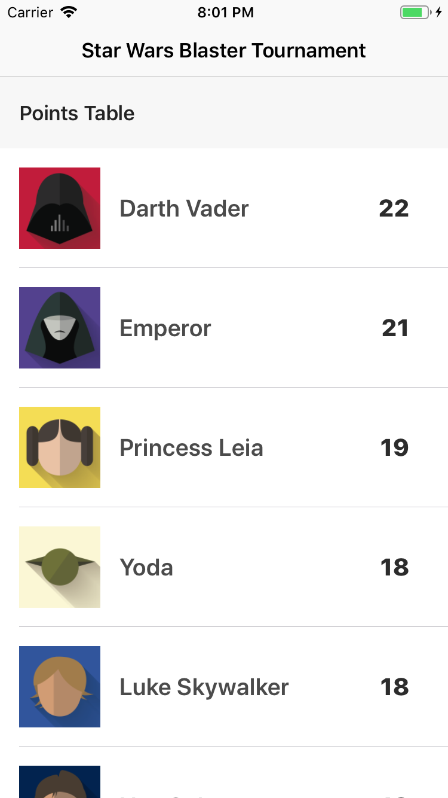 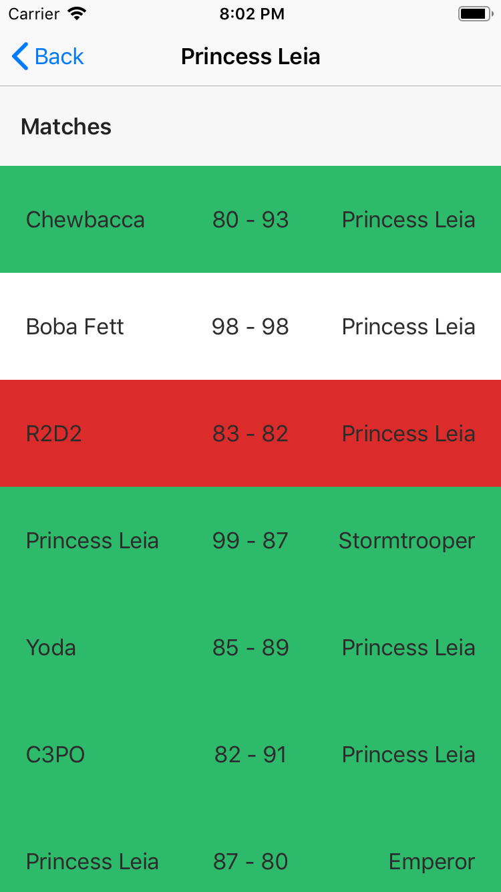

**Expectation**:

1. The UI should be as shown in the illustrations. Lot of polishing of UI is NOT needed.
2. Code should be complete and correct.
3. Code should be clean, readable, modular, extensible
4. The proper naming convention of the language used should be followed

**The extension should be:**

1. In the points table, the list should be sorted in descending order.
2. In case of a tie in the point table, the tie should be resolved lexicographically with respect to the player’s name. (Emperor gets precedence over Yoda).

All the data needed to create the app can be downloaded from the folder provided. (Please note that you can download the JSON file and bundle with the app, no need to write a network layer for same)